Skipjack Races Then and Now
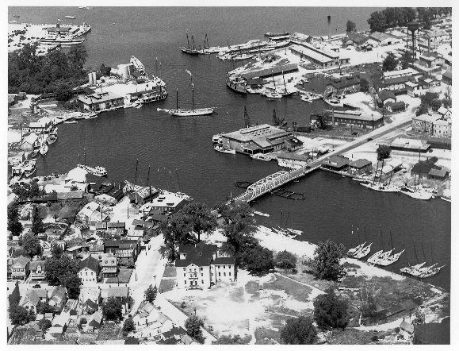
Sail powered workboat races started in 1872 when local watermen took their boats and crews out on shakedown sails before the start of the oyster season. Whenever two or more boats are out on the water together, rivalries were formed, and side bets were made. Informal races occurred up and down the bay from Havre de Grace to Solomons Island and were popular at Crisfield, Rock Hall, Claiborne, Annapolis, Oxford, Cambridge, and Deal Island.
The introduction of the marine gasoline engine led to many sail-powered boats losing their masts as they converted to power.
Cambridge harbor shows a mix of sail and motor-powered vessels in this picture
The commercial sail powered boat population on Chesapeake Bay dropped from about 2,000 sail craft of all sizes in 1910 to about 700 sail powered boats by the mid nineteen twenties. Today only about 20 skipjacks remain from this once mighty sail powered working fleet.

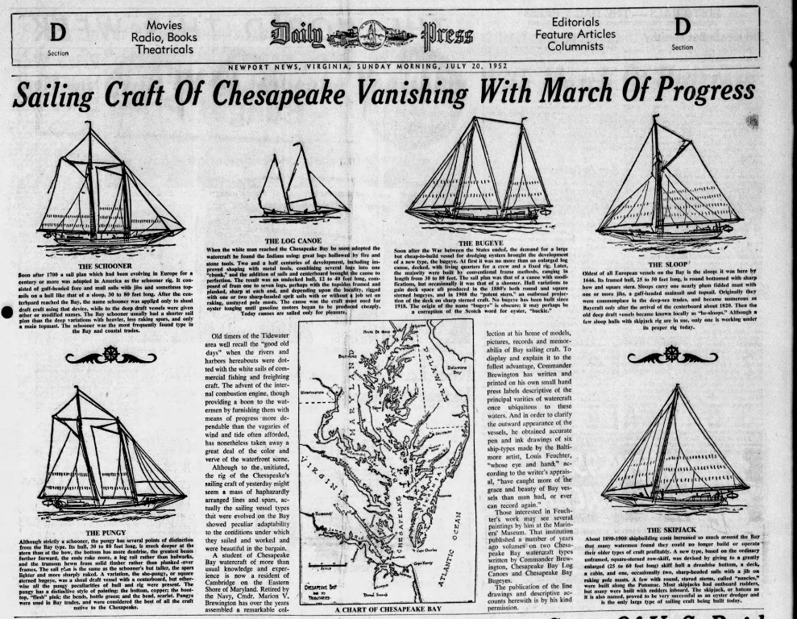
Of the Chesapeake Bay boats illustrated, working log canoes no longer exist, but racing log canoes survive and can be found racing on the Miles, Tred Avon, and Choptank Rivers. The pungy Lady Maryland is the sole remaining example of this type of vessel. Edna Lockwood survives as the last surviving active bugeye. The last oyster sloop was the J T Leonard, scrapped in the 1970’s, although the hull of oldest surviving skipjack, Rebeca T Ruark carries the lines of a sloop. Schooners exist as pleasure boats but only the skipjack remains active as the nation’s last sail powered work boat, dredging for oysters. Today about 20 skipjacks survive to represent the once mighty working fleet of Chesapeake Bay sail powered watercraft.

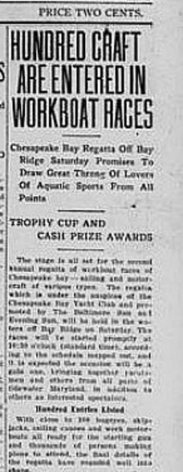
As working sailing craft disappeared at an alarming rate, efforts were made to keep traditional sail powered boats in operation. With sponsorship from the Baltimore Sun newspapers and political support from the governor of Maryland, Chesapeake Bay Championship Workboat Races became popular events in the 1920’s. Excursion trains filled with spectators and extra ferry service was added between Annapolis and Claibourne. Several thousand spectators watched the first race held off Claiborne in Talbot County and the races were a big success.
There were all types of Chesapeake Bay working sailing craft in attendance. Bugeyes over 50 ft in length raced in one category and smaller bugeyes raced in a second category for these distinct boats. Skipjacks and sloops raced together in their own categories, depending on the size of the boat. Working (log) canoes had their own race and racing log canoes had their own race.
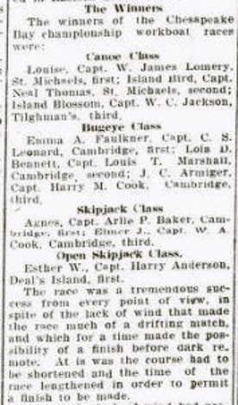
Choptank River bugeyes and skipjacks dominated these races. “Cambridge boats showed boats up and down the Bay that they were clear winners.” First prize in each race category was $100, a new set of sails, and a trophy. The Cambridge skipjack Agnes placed first; Oxford skipjack Elmer E placed second with Rebecca T Ruark coming in third. (Incidentally, the Rebecca T Ruark won the 2025 race in Cambridge).
Chesapeake Bay Championship Workboat Races became very competitive and winning brought much prestige. Boats from each port competed against each other and the fastest boats from each town competed in the yearly statewide workboat races. Governors and dignitaries from Washington watched the races from the steamer Gov McLane flagship of Maryland’s oyster navy.
Before the great depression cancelled the event, 99 boats participated in the race at Deal Island. There were so many boats that closed deck (larger) skipjacks competed in their own category and a separate category was established for a dwindling number of open deck (smaller) skipjacks. The smaller open deck skipjacks had all but disappeared by 1940.

A report on the 1921 State races at Claiborne follows. Note there were both skipjacks and “open deck skipjacks”. Open deck skipjacks were smaller boats that used hand scrapes (like Nathan of Dorchester uses to dredge). Designed when there were two types of oyster grounds for dredging, working open deck skipjacks disappeared by 1940; some converted to yachts or to yard decorations. “Canoes”, refer to log canoes, some still dredged for oysters, others like Island Bird are classic racing boats.

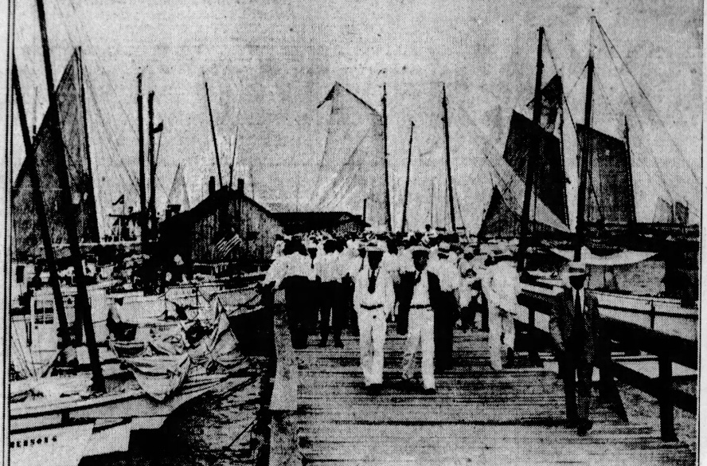

Clayborne, with a population of about 100 people, hosted several large skipjack races. Special excursion trains, and extra ferry service to Claiborne from Annapolis and Delmarva cities,
Shown dressed in their “bib and tucker”, spectators and dignitaries look at local boats during pre-race activities.
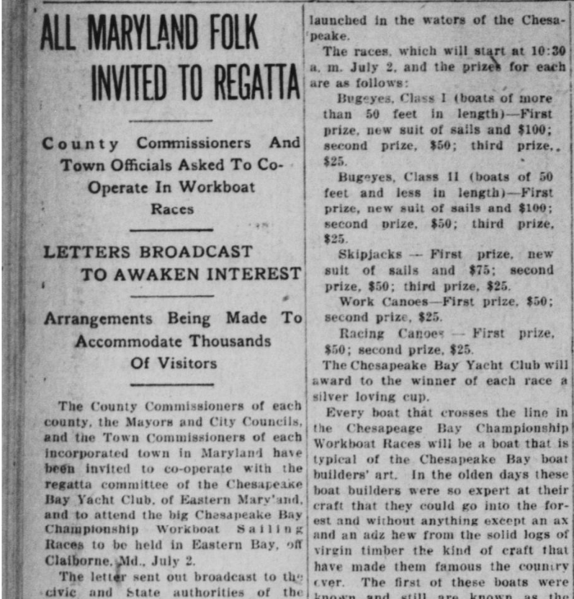
Maryland and Virginia governors and many VIPs attended the races. The Claiborne race was as popular as the Preakness, at a time when sail powered work boat races were major sporting events!

Invitations were extended to boats from Maryland and Virginia.

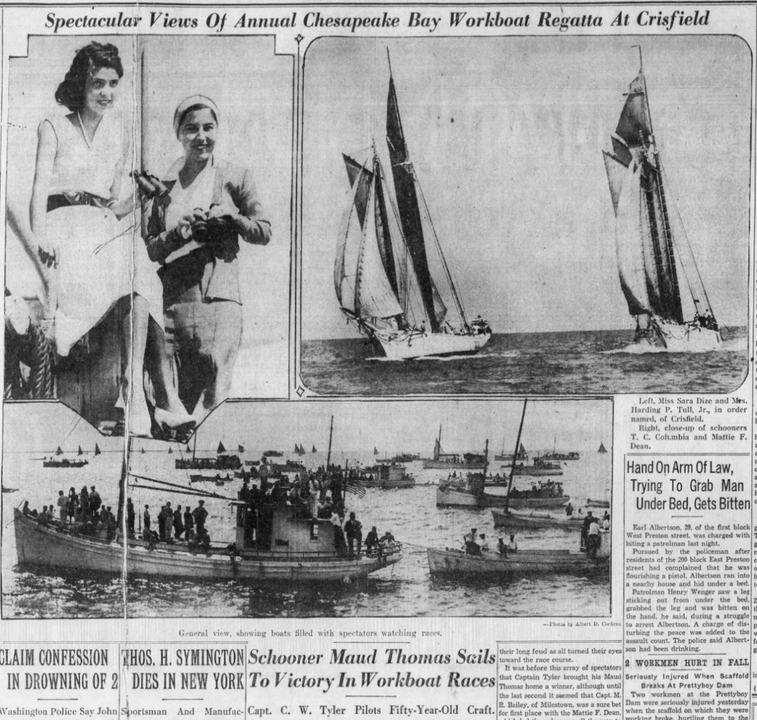
The Baltimore Sun newspaper featured an article about the Crisfield race of 1930.
Miss Skipjack of Crisfield poses with Mr. Skipjack.

Two schooners race side by side and many buyboats and other watercraft were used to carry spectators to view a full card of races..

T

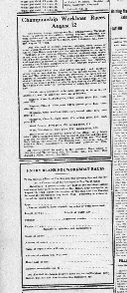
The Cambridge Banner published the following entry form for the Annapolis race. Note the number of boat categories and the prize money. Schooners and Pungy’s had disappeared by that time. Today’s races feature skipjacks, the remaining survivors of the sail powered work boat fleet.

Ther great depression ended the popular workboat races of the 1920’s. Postponed by World War 2, races resumed in the 1950’s to bring tradition back to watermen’s communities

In 1957, more than 80 skipjacks still plied the waters of Chesapeake Bay. By 1985, when the skipjack was officially designated the State Boat of Maryland, fewer than 30 licensed and working skipjacks sailed the Bay. Today, about 6 of the surviving skipjacks still dredge oysters, but they always dredge under power. The days of sail powered commercial oyster dredging are quickly fading from memory.

The Deal Island race in 1981 was not without some drama when a new fiber glass boat caught fire. With the loss of many traditional types of sail powered or wooden workboats, fiberglass boats began their own competition, racing and docking competitions gaining popularity. Today fiberglass work boats compete in action filled docking contests dominated by the Chesapeake Cowboys.
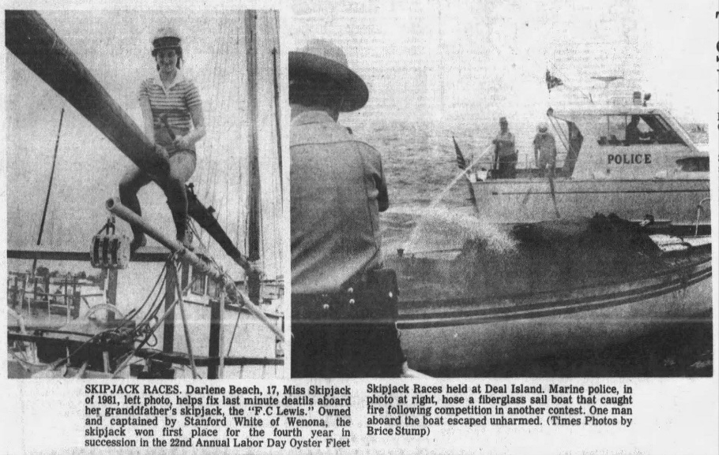
Miss Skipjack continues to be a feature at Deal Island festivities and is shown on the skipjack F C Lewis which was scrapped in 2026.
The Lewis was fiber glassed in attempt to save her. However, the fiberglass trapped moisture in the solid wood hull. At the end, only the fiberglass shell that once encased her hull remained as F C Lewis rotted away.
TIDES, TIMBER, and TRADITION
Skipjack Races Today.
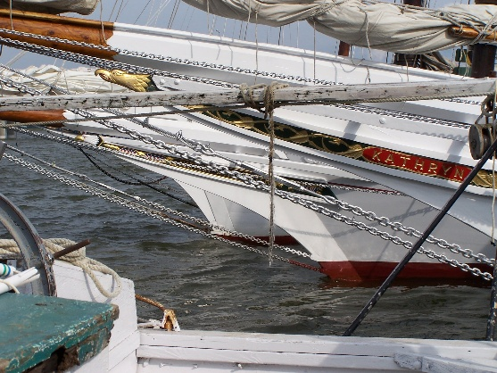
Skipjacks awaiting the start of the race
Note the sharp clipper bow and colorful trail boards, each decorated with a patriotic theme. Only the trail board (nameboard) survived from boats scrapped and all but forgotten.
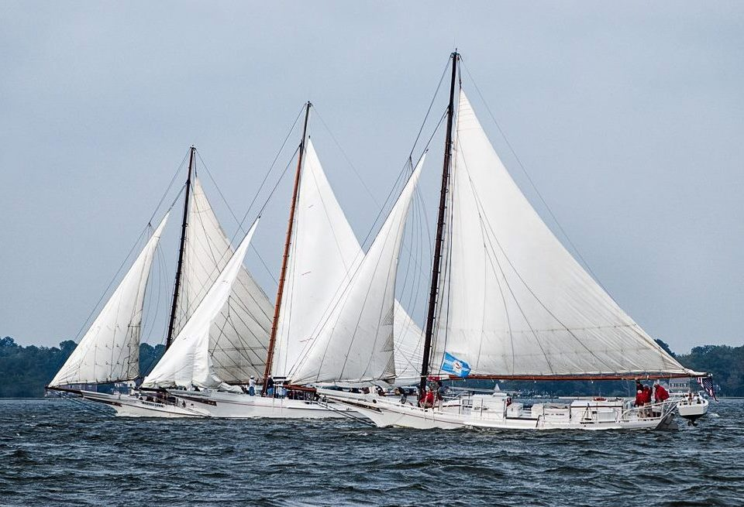

Boats are lined up to start the race. Nathan of Dorchester is in the foreground.

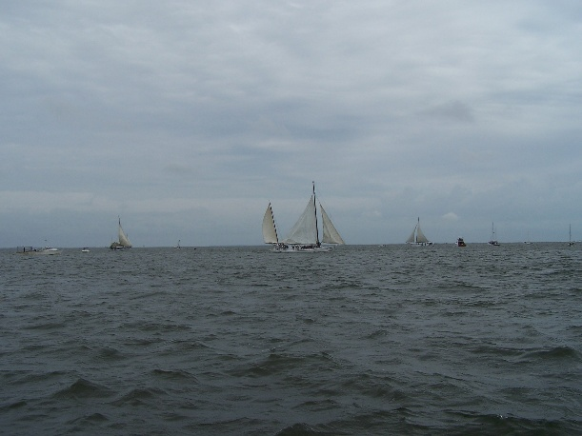
Today three skipjack races remain.
The Deal Island Labor Day skipjack race and carnival is now in its 62nd year. This race is held out in Tangier sound and is a competition between local skipjack families wh o know where all those crab pots are located and easily avoided and visiting skipjacks whose captains must find and avoid becoming tangled with those elusive crab pot floats. The Deal Island race is best seen with strong binoculars or by boat.

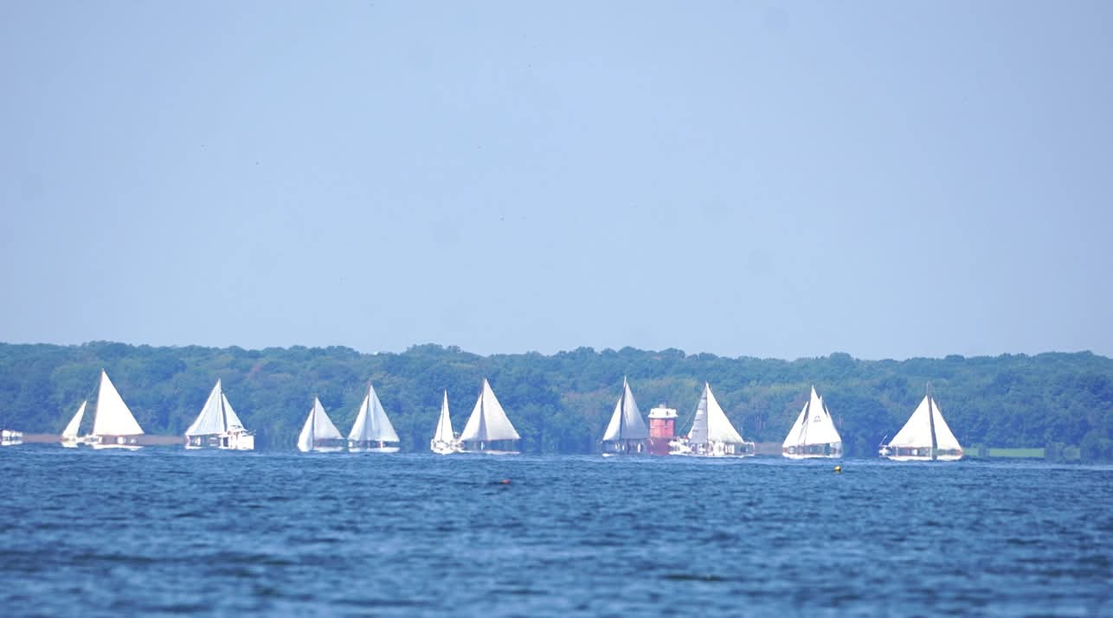
In 2025 the Annapolis skipjack race resumed after a 35-year absence. This race is held in conjunction with the Maryland Seafood Festival at Sandy Point State Park, just north of the Chesapeake Bay Bridge. Skipjacks are docked at Sandy Point Marina for visitors before the race. The race is best viewed from the park or from stalled westbound traffic on the bridge!

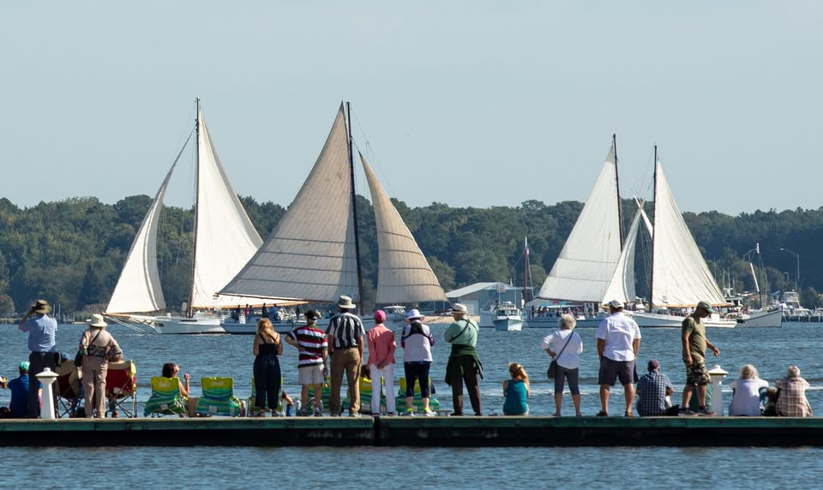
The 30th Choptank Heritage Skipjack Race will be held September 26rd in Cambridge. The race is sponsored by the Dorchester Skipjack Committee and the host Skipjack Nathan of Dorchester. This race starts and finishes by the Cambridge lighthouse and offers spectators an excellent view of the race. A parade of boats will head out of Cambridge Creek at 10 a.m. and racing begins at 11 a.m. The best view is from the floating dock at Long Wharf Park, at the foot of High and Water Streets in Cambridge, MD.

The race is held to preserve the remaining skipjacks. Each participating skipjack receives approximately $1500 in show-up money, for boat maintenance and preservation. Over the past 20-plus years, the Dorchester Skipjack committee has raised and donated over $200,000 to help preserve the skipjack fleet.

The race is a free event but there will be an opportunity to help keep our skipjacks afloat. Contributions can be placed in our race day “Donation Dingy” or by credit card or PayPal through our web site www.skipjack-nathan.org.

The Dorchester Skipjack Committee, Inc., is a 501(c)3 nonprofit organization. Your donations are tax-deductible to the extent allowed by law.
Donations also may also be made payable and mailed to:
The Dorchester Skipjack Committee, Inc.
P.O. Box 1224
Cambridge, MD 21613
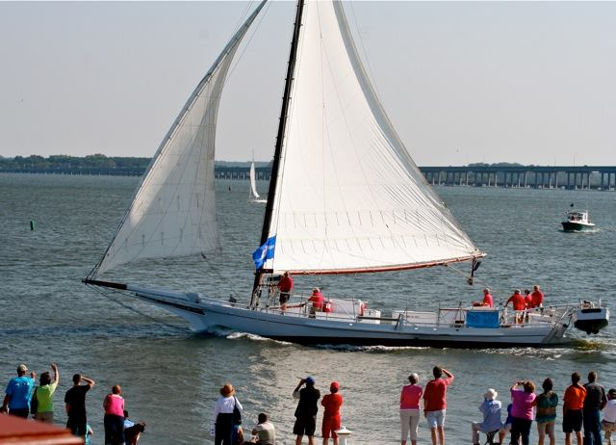

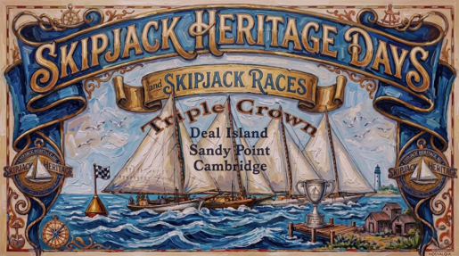

Information compiled by Bud Marseilles Dorchester Skipjack Committee

